A* ALGORITHM

Aim
To implement the A* (A-Star) Search Algorithm in Python to find the shortest path from a start node to a goal node using heuristic values.
Objective
- To understand the working of the A* search algorithm.
- To find the optimal path between the start and goal nodes.
- To use heuristic values for efficient path searching.
- To implement the algorithm using Python with manual input.
Algorithm
- Start the program.
- Read the graph, edge costs, and heuristic values from the user.
- Enter the start node and goal node.
- Add the start node to the open list.
- Select the node with the minimum f(n) = g(n) + h(n) value.
- If the selected node is the goal node, display the path and stop.
- Otherwise, expand its neighboring nodes.
- Update the cost and parent of each neighboring node if a shorter path is found.
- Repeat Steps 5–8 until the goal is reached or the open list becomes empty.
- Stop the program.

Flowchart:
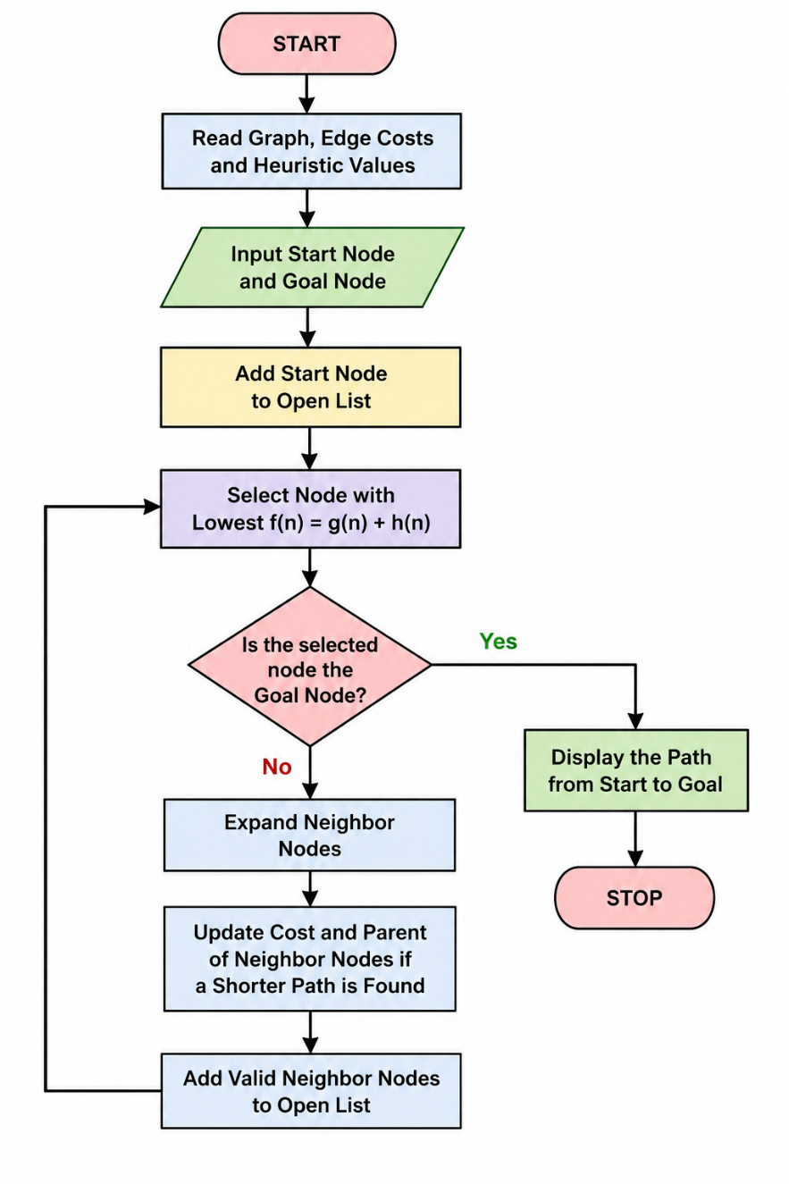

Python Code:
graph = {}
n = int(input("Enter number of nodes: "))

for i in range(n):
node = input("Node: ")
graph[node] = {}
e = int(input("Edges from " + node + ": "))
for j in range(e):
v = input("Connected node: ")
c = int(input("Cost: "))
graph[node][v] = c

h = {}
for i in graph:
h[i] = int(input("Heuristic of " + i + ": "))

start = input("Start node: ")
goal = input("Goal node: ")

open = [start]
cost = {start: 0}
parent = {start: None}

while open:
x = min(open, key=lambda i: cost[i] + h[i])
open.remove(x)

if x == goal:
path = []
while x:
path.append(x)
x = parent[x]
print("Path:", path[::-1])
break

for y in graph[x]:
g = cost[x] + graph[x][y]
if y not in cost or g < cost[y]:
cost[y] = g
parent[y] = x
open.append(y)
Output:
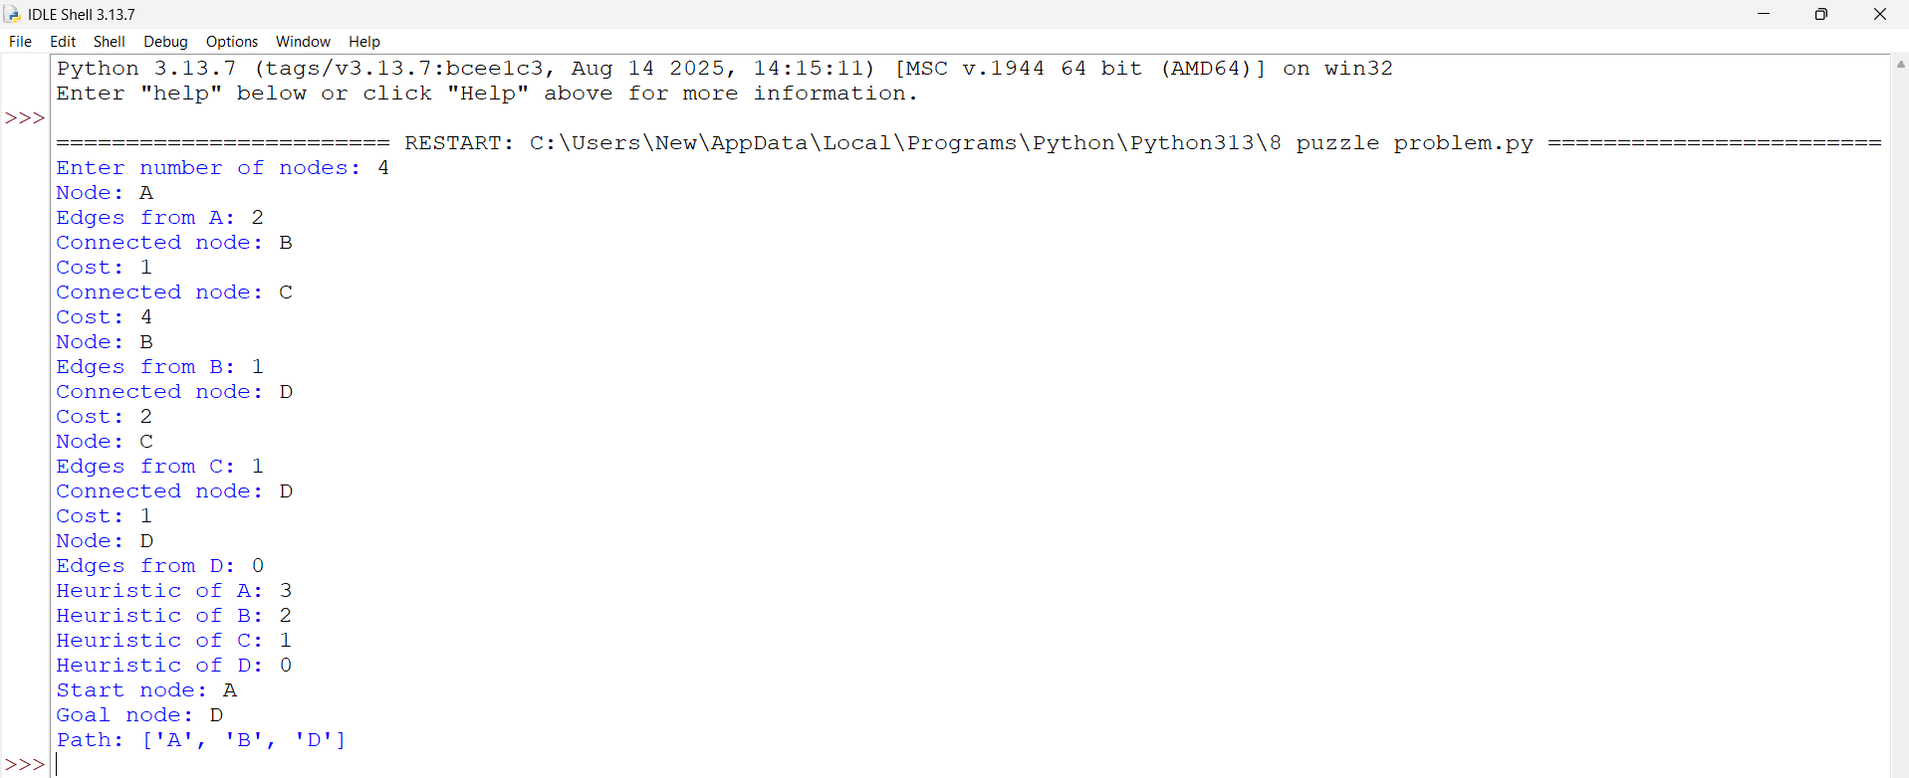
Result:
The A* Search Algorithm was successfully implemented in Python. The algorithm efficiently found the shortest path from the start node to the goal node using the heuristic values and path costs.

